**Mapping the Electric Field**

**Pre-lab questions:**

1. What is the goal of this experiment? What physics and general science concepts does this activity demonstrate?
2. What is a line of equipotential? What angle do lines of equipotential make with the electric field lines?
3. Does one have to do work to move a charged particle along a line of equipotential?
4. What is the convention for electric field line direction – on which type of charge do they originate and on which type of charge do they terminate?
5. Can electric field lines ever cross?
6. How does the density of electric field lines relate to the strength of the field at that location?

**Equipment:**

[Instructor note: PASCO Universal 850 may be used in place of some equipment. See PASCO lab manual #73 for details.]

* Electric field mapping cork board
* Metallic push pins
* Connecting cables with alligator clips
* DC power supply (or PASCO 850 power supply)
* Carbon paper with electrodes
* Copy of carbon paper grid (white paper)
* PASCO voltage sensor
* Ruler
* Protractor

The goal of the experiment is to study the characteristics of the electric field by mapping the equipotential lines and constructing electric field lines of various charge configurations.

**Introduction:**

Surrounding any charge or group of charges is a region known as an **Electric Field** in which the effect of the presence of these charges is felt. If we suppose that a small positive test charge q0 is brought into this region and at a particular point it experiences an electrostatic force **F**, then we say the electric field intensity at that point is the vector **E** defined as: $\begin{aligned}E=\frac{F}{q_{0}}\#\left(1\right)\end{aligned}$

Electric lines of force have been used since the time of Michael Faraday (1791-1867) to graphically represent the magnitude and directions of electric fields. Each line is drawn such that at every point its tangent gives the direction of the electric field and the number of lines per unit cross-section area is proportional to the magnitude of the electric field vector. Each line originates at a positive charge and terminates at a negative charge. Lines repel each other and never cross filling all the space around the charge.

The electric field can be described not only by the electric field vector **E** but also by a scalar quantity, the **electric potential V.** The electric potential difference between two points A and B is defined to be a **voltage** and it is a work done per unit charge in moving the charge between the two points:

$$\begin{aligned}V_{B}-V_{A}=\frac{W}{q_{0}}\#\left(2\right)\end{aligned}$$

### The unit of voltage is the Volt and it is the Joule per Coulomb.

### If point A is chosen to be an infinite distance from all charges and the electric potential there is assumed to be zero, the electric potential at point B with respect to infinite point A is:

$$\begin{aligned}V=\frac{W}{q_{0}}\#\left(3\right)\end{aligned}$$

The locus of points, all of which have the same electric potential, is called an **equipotential** line. No work is required to move a charge between any two points on an equipotential line. This follows from equation (2):

if VB = VA , then work W = 0.

Because no work is required to move a charge along the equipotential line, it could be only if the equipotential lines are perpendicular to the electric field lines. This rule helps to visualize the electric filed lines. If the equipotential lines are drawn, the electric field lines can be constructed: they intersect the equipotential lines at right angle at all points. An example of the equipotential and field lines is shown on Figure 1 where equipotential lines (broken lines) and electric field lines (solid lines) of electric field are produced by two equal and opposite charges.

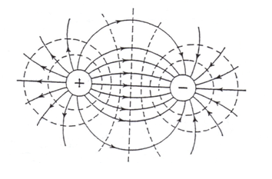

Figure 1: Schematic of equipotential lines (dashed) and electric field lines (solid with arrows) surrounding two circular point charges.

In this particular experiment, an electric field is produced in the high-resistance carbon impregnated paper that forms the conducting medium between the electrodes. Because the paper has a finite resistance (resistance range of 5 kΩ to 20 kΩ per square), a current must flow through it to produce a potential difference. The conductive electrodes supply this current, which causes a potential drop to occur across the paths.

Points of equal potential are detected by setting the fixed probe of the potential measuring instrument at one of the electrodes with a second movable probe located at some arbitrary point on the paper sheet, as shown at Fig.2. Moving this probe along the surface of paper you can find out other points with the same potential reading. These points are plotted on coordinate paper and connected to plot an equipotential line. When the entire field is thus explored, the lines of electric field are drawn so that they are everywhere perpendicular to the equipotential lines.

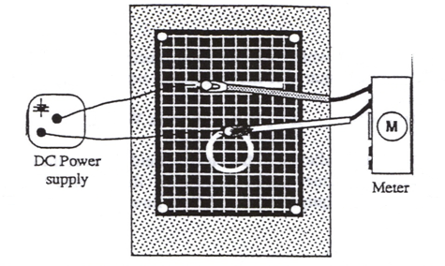

Figure 2: Schematic of electric field mapping apparatus.

## Experiment:

***Set up***

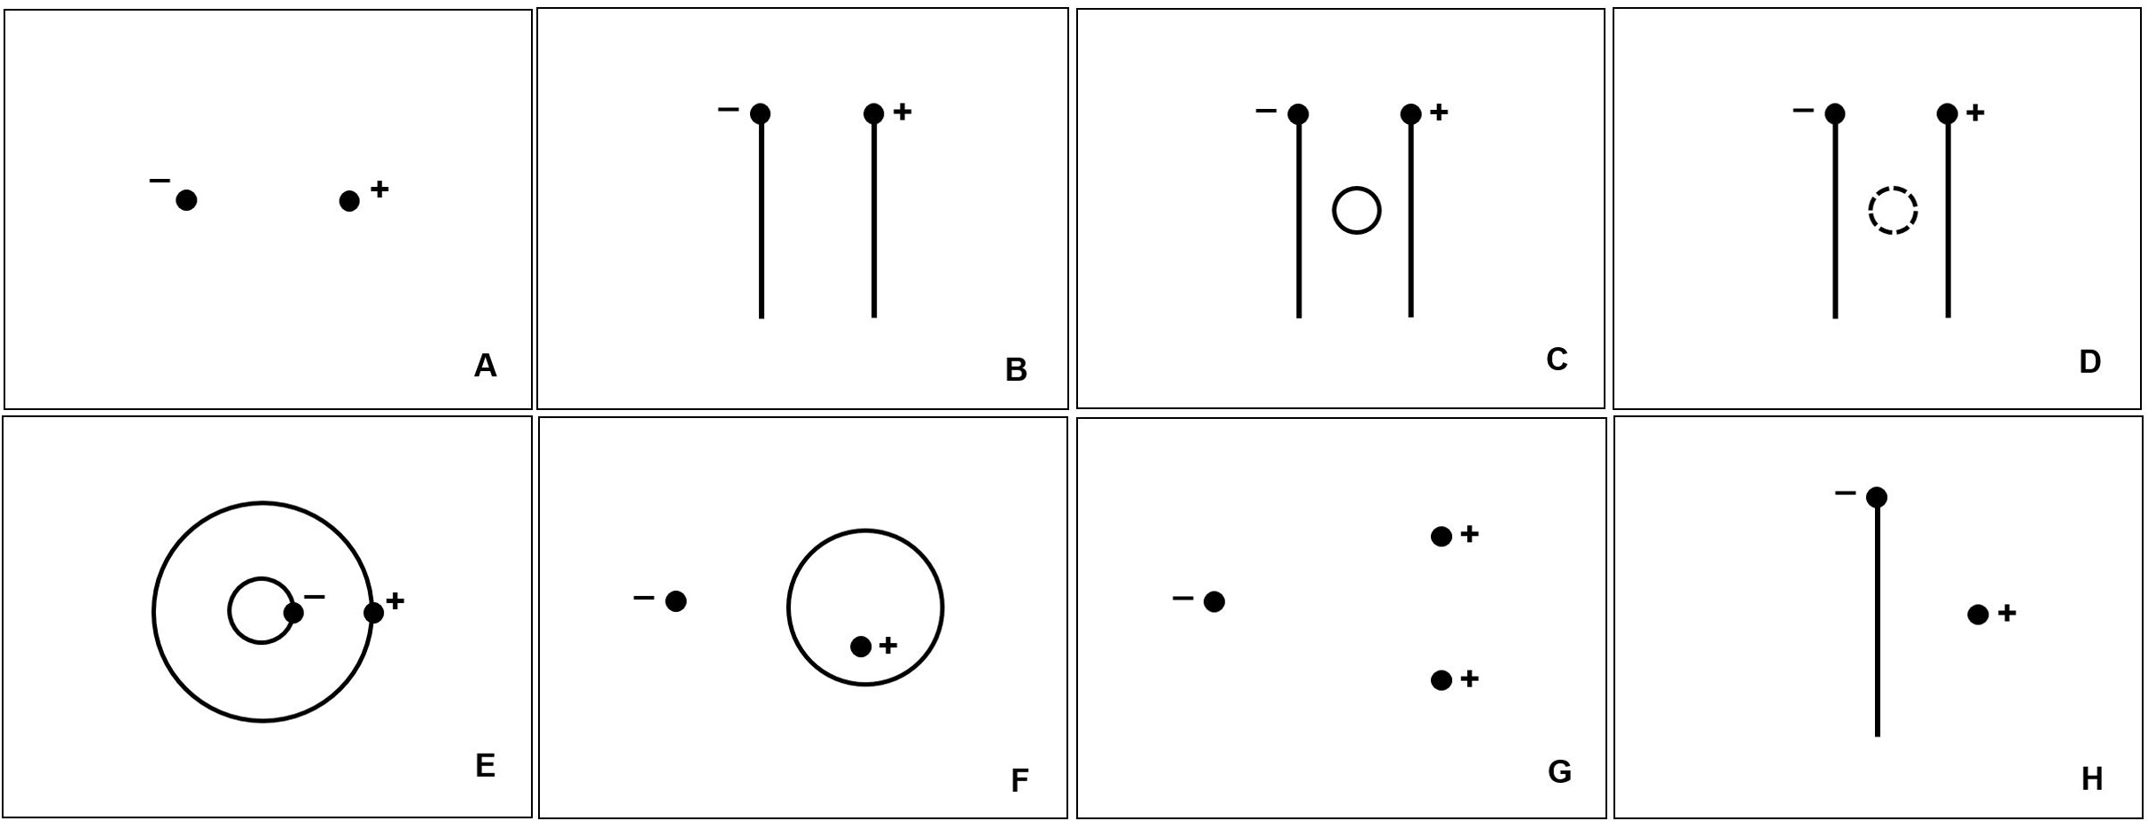

Figure 3: Suggested electrode patterns. The dots represent the position of push pins where power supply leads are attached.

* Mount the conductive paper on the corkboard using one of the metal pushpins in each corner. The paper is not very conductive, but does carry a small amount of current. This does affect the electric field, and this effect is most noticeable near the edges of the paper.
* Connect the electrodes to the power supply using the supplied connecting wires (Figure
  + For this, place the terminal of a connecting wire over the electrode then stick a metal pushpin through its terminal and the electrode into the corkboard.
  + Make certain that the pin holds the terminal firmly to the electrode. (see Fig.3).
  + Then connect the other end of the wire to the voltage supply.
  + *It is important that you do not bump the electrode push pins during the experiment since doing so may change the voltages on the paper. This is not a disaster since the shapes of the equipotential surfaces will not be affected, but it is frustrating to be tracing a 4.0 V surface that suddenly becomes a 3.0 V surface.*

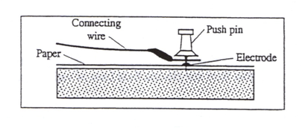

Figure 4: Schematic of electric field apparatus electrode connection.

* To check if electrodes have proper conductivity connection, touch both pushpins with the voltage sensor leads and read the voltage scale, then touch the metal ink electrodes on the paper with the voltage sensor leads. The readings should be the same or within 1% of the potential applied between the two electrodes. (Take care not to punch through the paper with the probes)

***Procedure – Mapping lines of equipotential:***

* Equipotentials are plotted by connecting one lead of the voltage sensor (the ground) to one of the electrode pushpins. This electrode now becomes the reference.
* The other voltage sensor lead (the probe) is used to measure the potential at any point on the paper simply by touching the probe to the paper at that point.
  + To map an equipotential, move the probe until the desired potential is indicated on the voltmeter.
  + Mark the grid on the corresponding white paper at this point with a pencil.
  + Continue to move the probe but only in a direction which maintains the voltmeter at the same reading.
  + Continue to mark these points at regular enough intervals on the white paper to enable you to draw the equipotential line.
  + Connecting the points produces an equipotential line.
  + Record the potential value for this line.
* Having finished one equipotential line, move the probe to another point on the sheet and repeat the same procedure. Continue in this manner until the entire field has been mapped. Draw at least 7 equipotential lines between the electrodes.

***Procedure – Mapping electric field lines:***

* To plot the electric field lines, first disconnect the power supply and voltage sensor and then draw the electric field lines, which are always perpendicular to equipotential lines, on the white marking grid paper. Draw enough lines (at least 7) to enable one to visualize the characteristics of electric fields.

**Data, Computations, and Analysis:**

We easily measured electric potential (V) and used that information to map the electric field. The relationship between electric field strength and electric potential is given by:

$$\begin{aligned} E=\frac{V}{d}\#\left(4\right)\end{aligned}$$

where “d” is the distance between the points where electric potential was measured – in this case it is the distance between the probes.

* Choose one electric field line (the shortest one between the electrodes) and measure the distances between the ground electrode and each of equipotential lines. Write the results of your measurements to the table provided and calculate the electric field.

Table 1: Electric potential difference and electric field as a function of distance.

|  |  |  |
| --- | --- | --- |
| **Distance d** [m] | **Potential diff. V** [Volt] | **Electric Field E** [V/m] |
|  |  |  |
|  |  |  |
|  |  |  |
|  |  |  |
|  |  |  |
|  |  |  |

* Create two graphs on the same grid:
  + [y-axis] Potential (V) vs. [x-axis] distance (d);
  + [y-axis] Electric field (E) vs. [x-axis] (d).

**Conclusions:**

Do your plots show the theoretical mathematical relationship between the variables of *V* and *d* as well as between *E* and *d*? Why or why not?

Describe the regions on your paper where the electric field is the strongest. Is there symmetry to the electric field? Include your hand-drawn map of the electric field with your lab submission.

What other observations can you make about mapping the electric field.

**Sources of errors:**

What assumptions were made that caused error? What is the uncertainty in your final calculation due to measurement limitations?

**Complete the following questions to demonstrate your understanding of the lab topic.**

**Questions:**

1. The diagram shows the electric field lines due to two charged parallel metal plates of a capacitor (side view shown). You can conclude that:

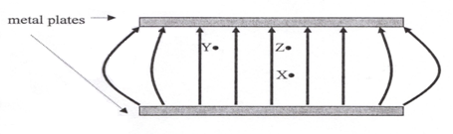

a) The upper plate has a positive charge and the lower plate has a negative charge

b) The upper plate has a negative charge and the lower plate has a positive charge

1. The upper plate has positive charge and the lower plate has zero charge
2. The upper plate has zero charge and the lower plate has a positive charge.

2. From the same diagram of electric field lines shown above, you can conclude that:

a) A positive charge at X would experience the same force if it would placed at Y

b) A positive charge at X would experience a greater force than at a point Z

c) A positive charge at X would experience less force than at a point Z

d) A negative charge at X could have its weight balanced by the electric force.

3. The electric field lines in some region of space in a figure shown represent:

1. a uniform electric field of constant strength
2. non-uniform electric field with its strength increasing

to the right

A

1. non-uniform electric field with its strength increasing to the left
2. Uniform electric field of varying strength

4. The electric field lines in some region of space are shown in a figure above. If a proton is released from rest at point A, how it will behave

1. It will move towards the right with increasing acceleration
2. It will move towards the right with constant acceleration
3. It will move towards the left with increasing speed
4. It will move towards the left with increasing acceleration
5. It will move towards the left with decreasing speed